How to Adjust Time Setting in the Beli app

When you set up a schedule for a smart home device, it will take effect based on the time you set in Beli app. Sometimes the time may be wrong and need to be adjusted. This guide will show you how to do this.

Step1: Open the Beli app, click the device you want to adjust.

Step2: Tap the “three dots” icon on the top right corner.

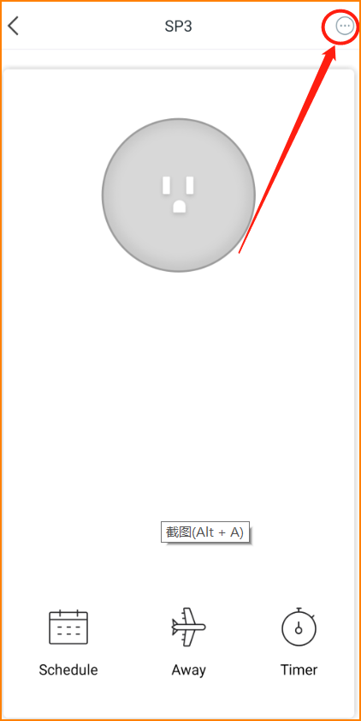

Step3: Tap “Time Zone”.

Step4: choose your current time zone. Now the work is done.

